**WEST HUNTER BINGO**

# loading

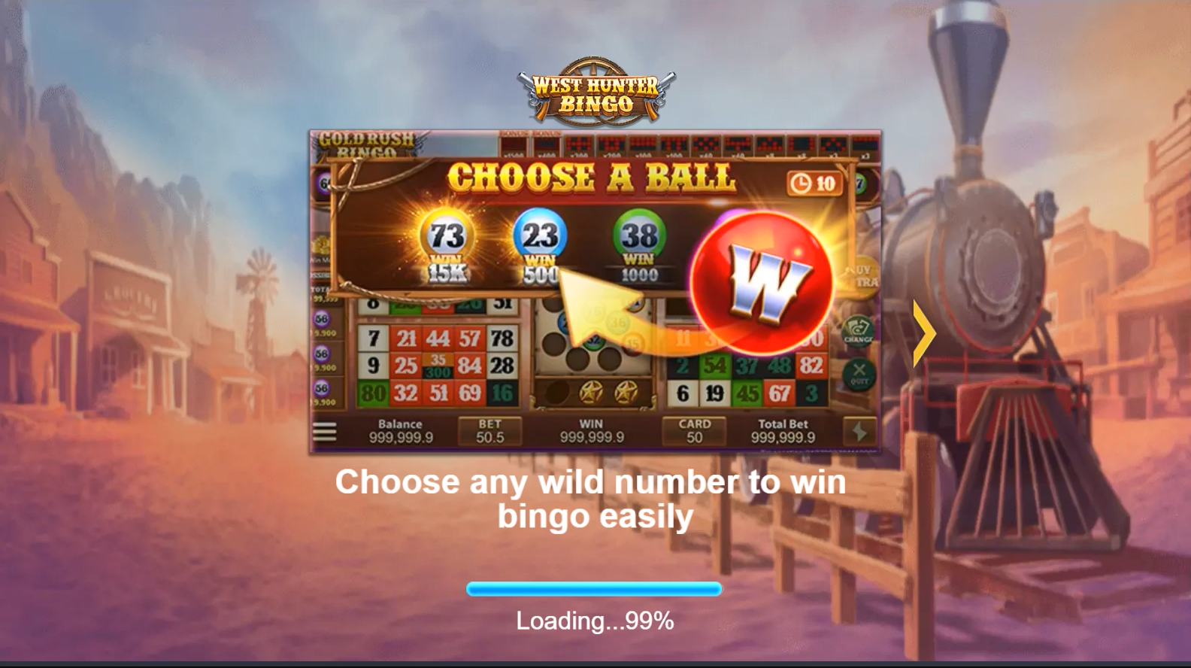

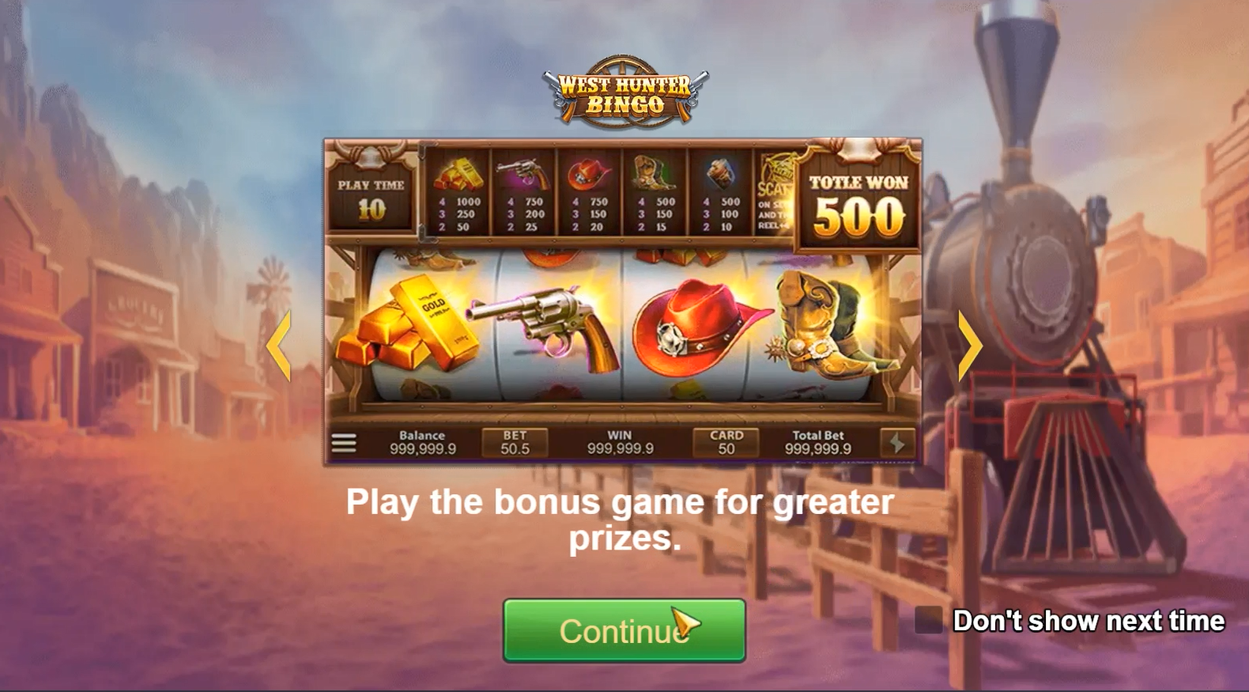

# Main game

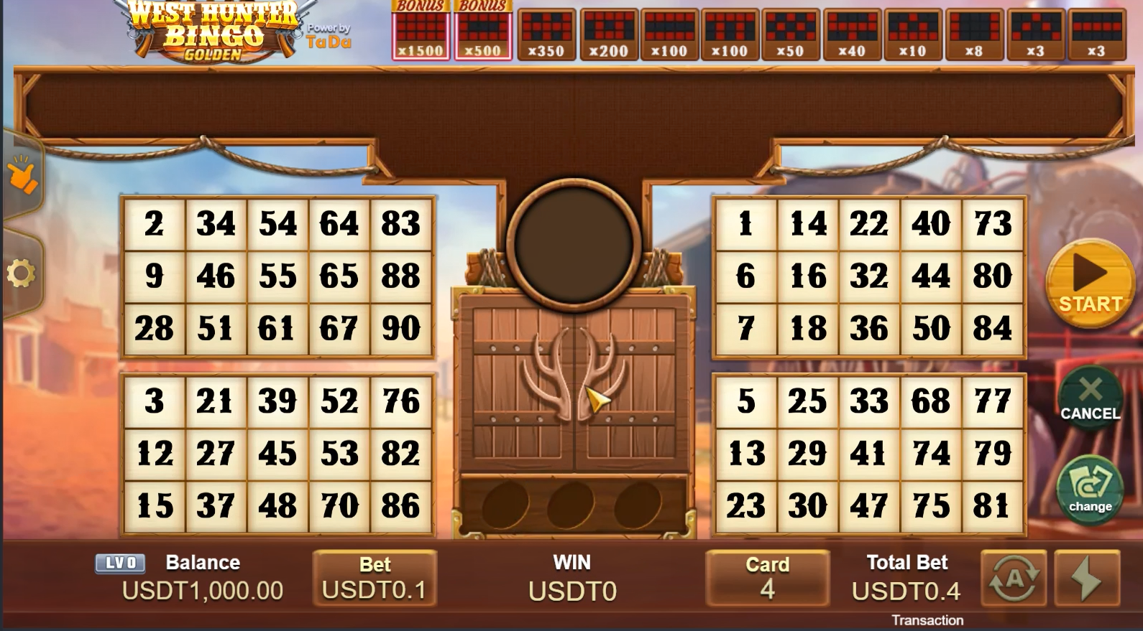

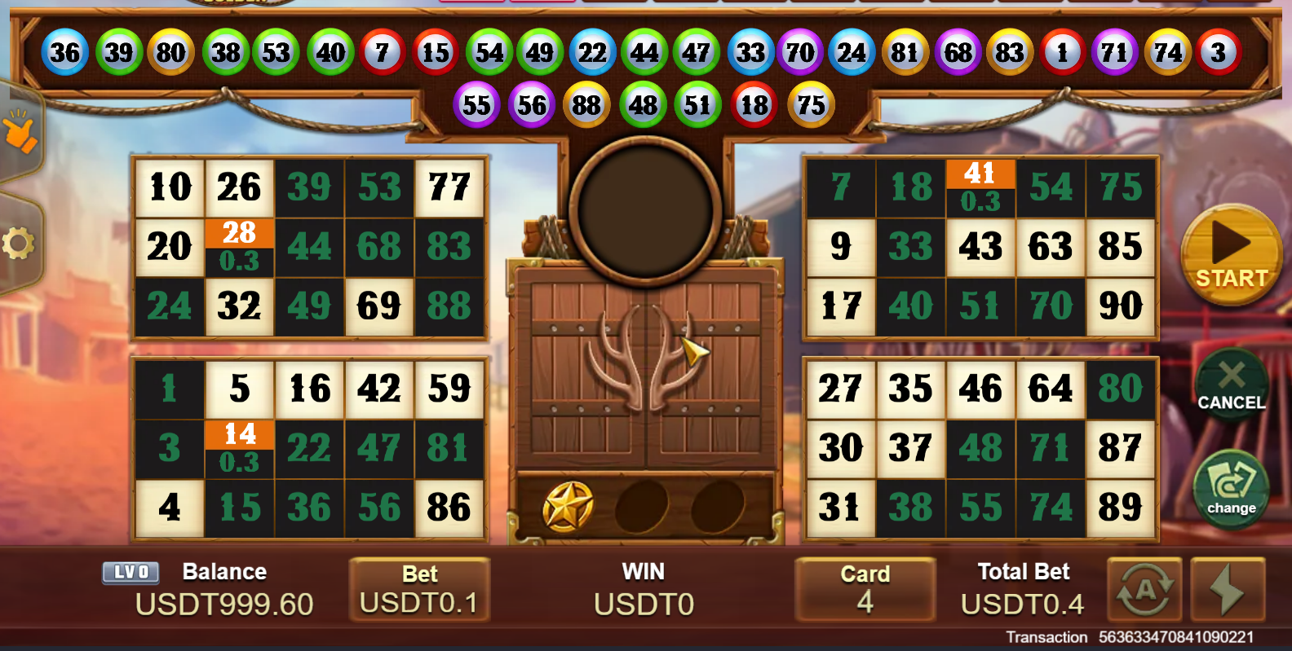

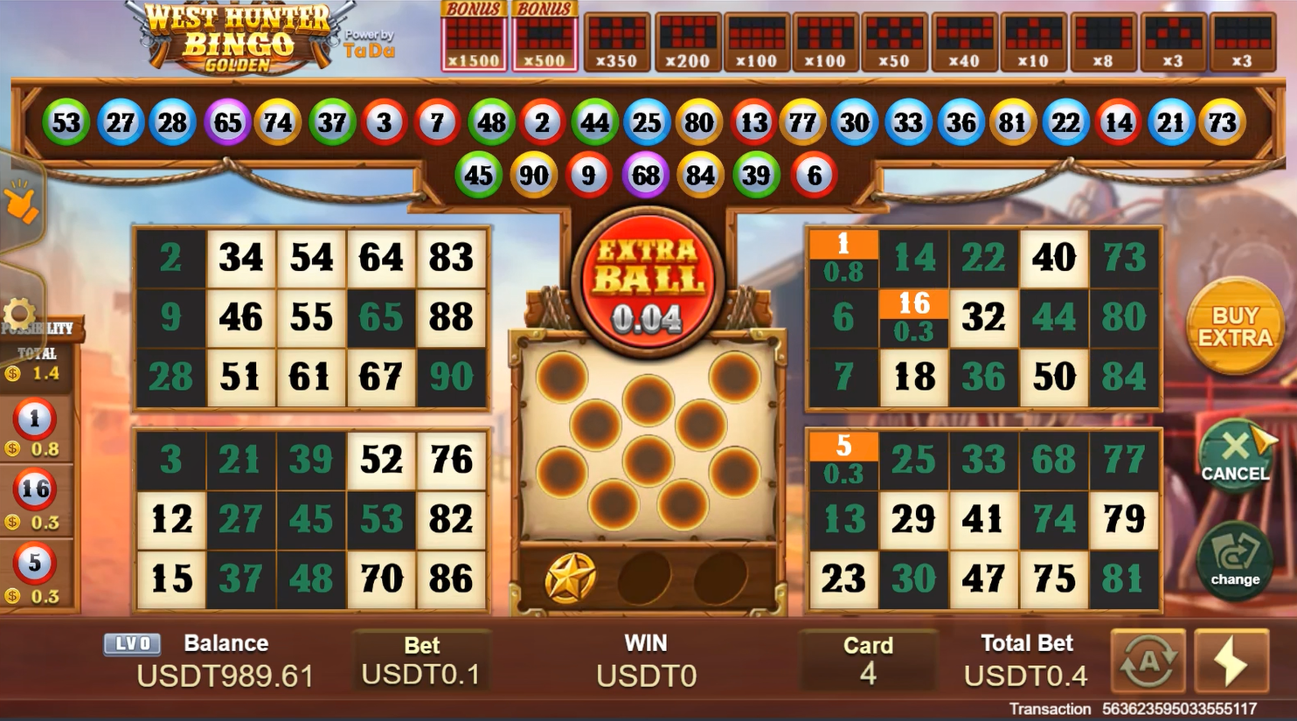

# Rules

## Bonus game

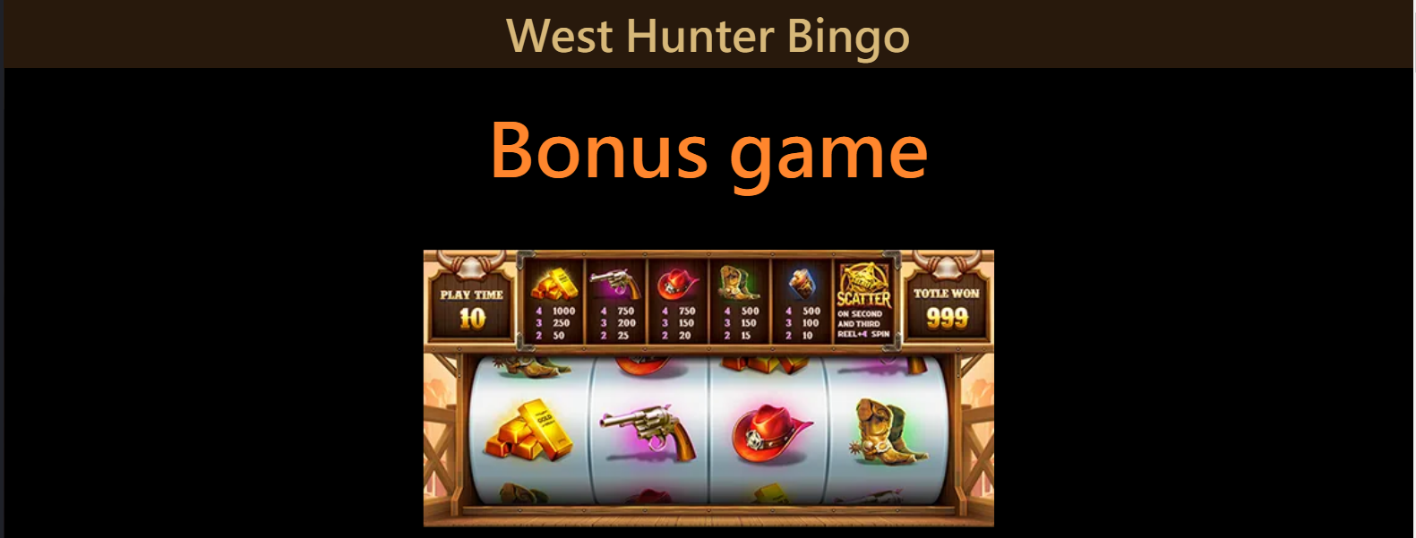

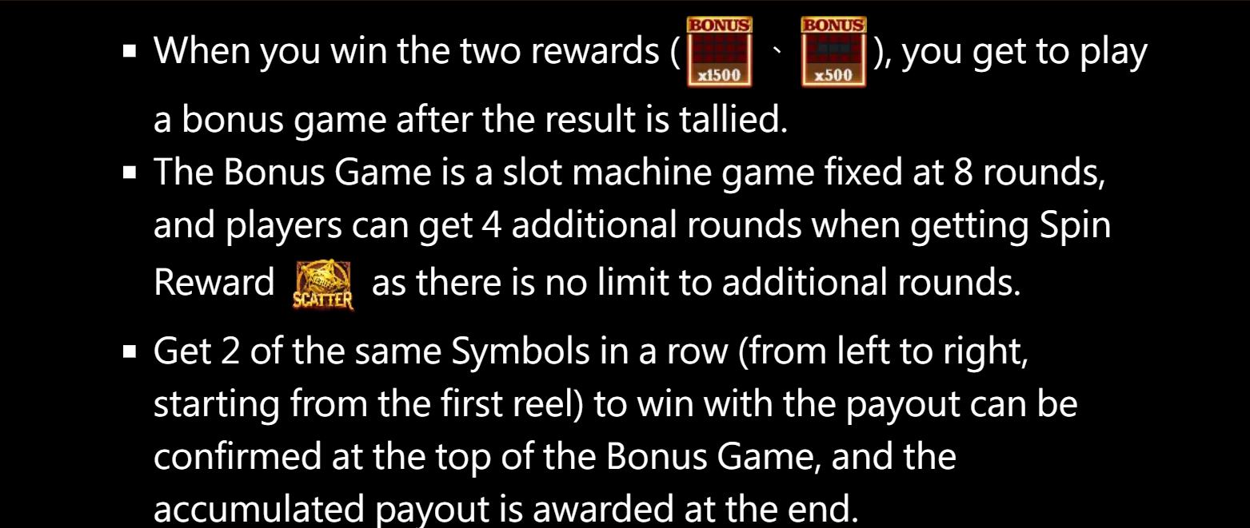

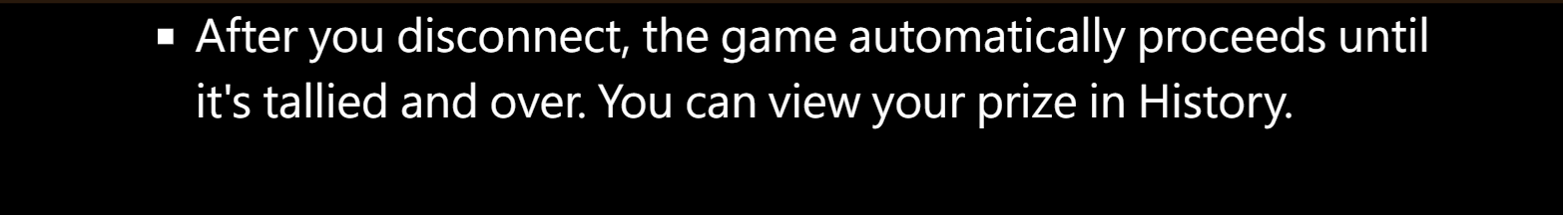

* When you win he two rewards(、),you get to play a bonus game after the result is tallied.
* The Bons Game is a slot machine game fixed at 8 rounds, and players can get 4 additional rounds when getting Spin Reward () as there is no limit to additional rounds.
* Get 2 of the same Symbols in a row (from left to right, starting from the first reel) to win with the payout can be confirmed at the top of the Bonus Game, and the accumulated payout is awarded at the end.
* After you disconnect, the game automatically proceeds until it’s tallied and over. You can vies your prize in History.

## WILD BALL

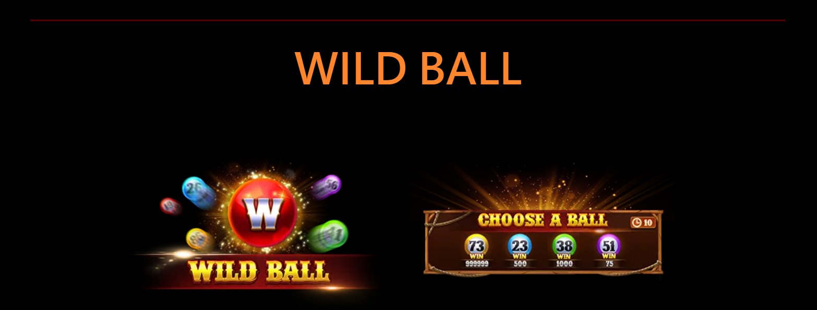

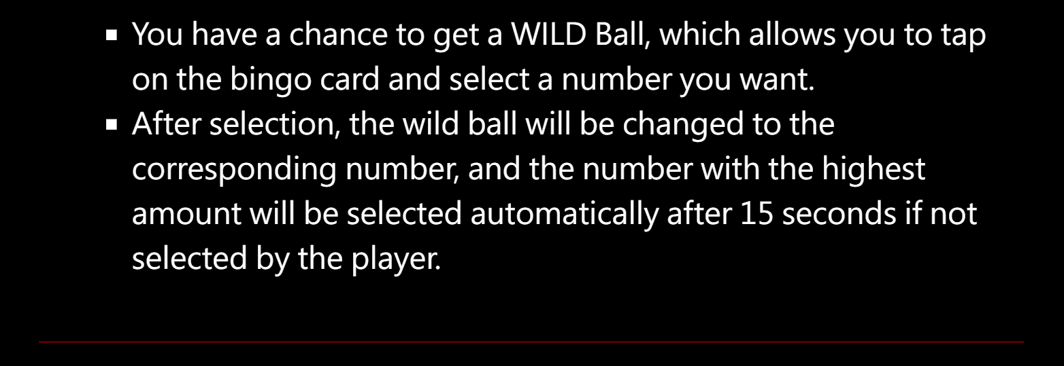

* You have a chance to get a WILD Ball，which allows you to tap on the bingo card and select a number you want.
* After selection, the WILD ball will be changed to the corresponding number, and the number with the highest amount will be selected automatically after 15 seconds if not selected by the player.

Golden BALL

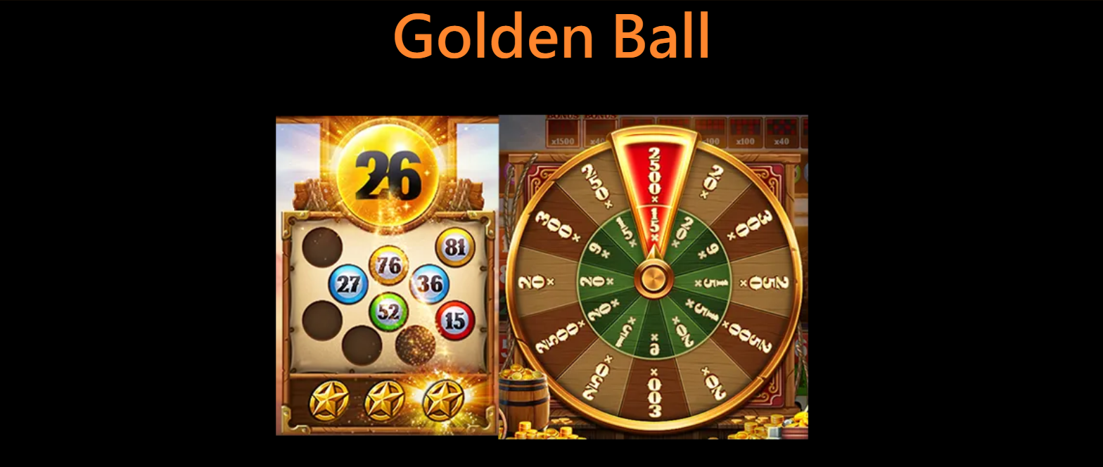

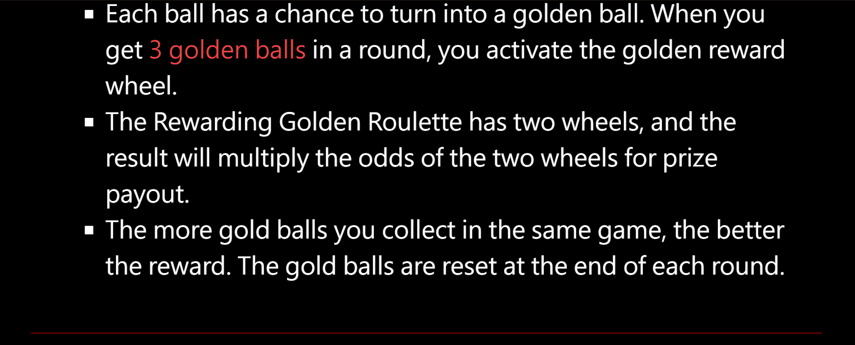

* Each ball has a chance to turn into a golden ball. When you get 3 golden balls in a round, you activate the golden reward wheel.
* The Rewarding Golden Roulette has two wheels, and the result will multiply the odds of the two wheels for prize payout.
* The more gold balls you collect in the same game, the better the reward. The gold balls are reset at the end of each round.

## Free BALL



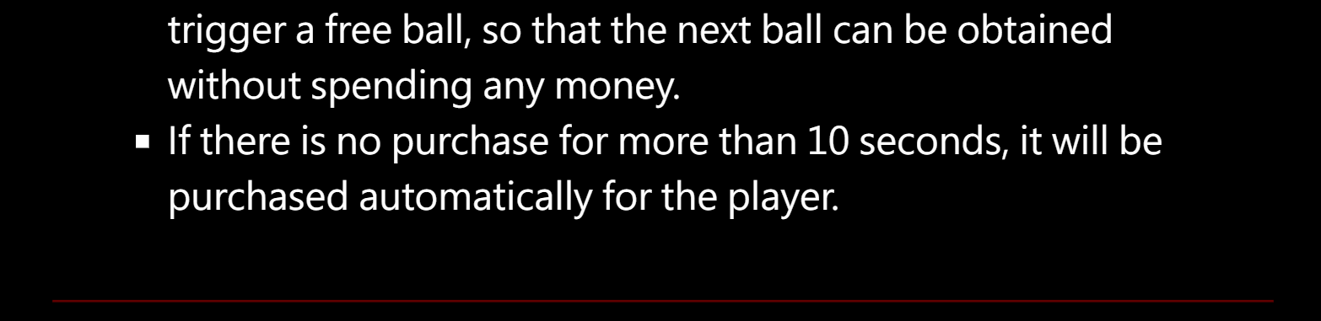

* During the extra ball purchase stage, there is a chance to trigger a free ball, so that the next ball can be obtained without spending any money.
* If there is no purchase for more than 10 seconds, it will be purchased automatically for the player.

## How to play bingo

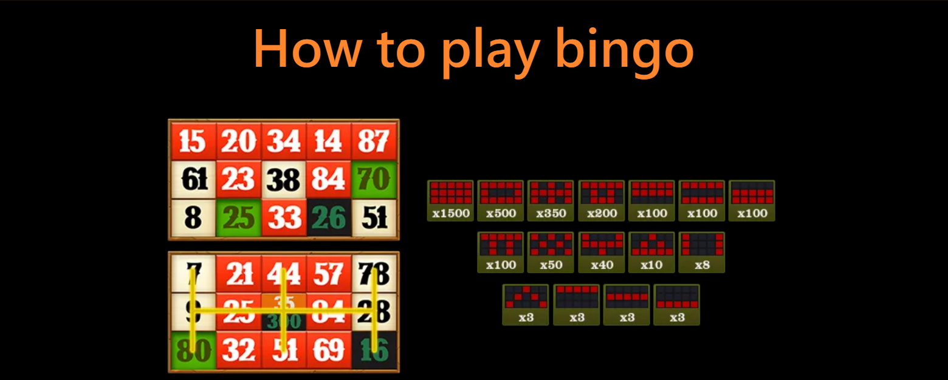

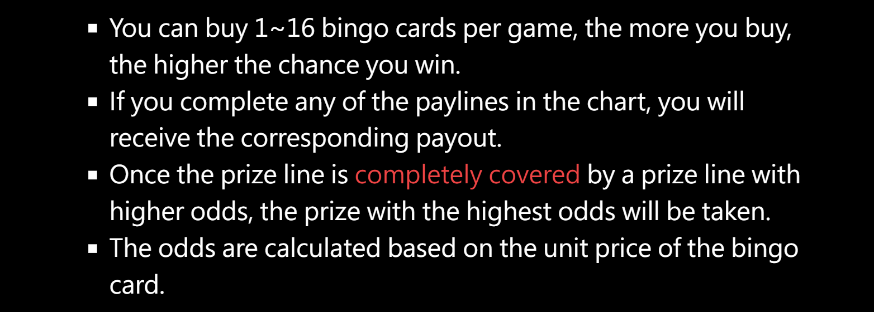



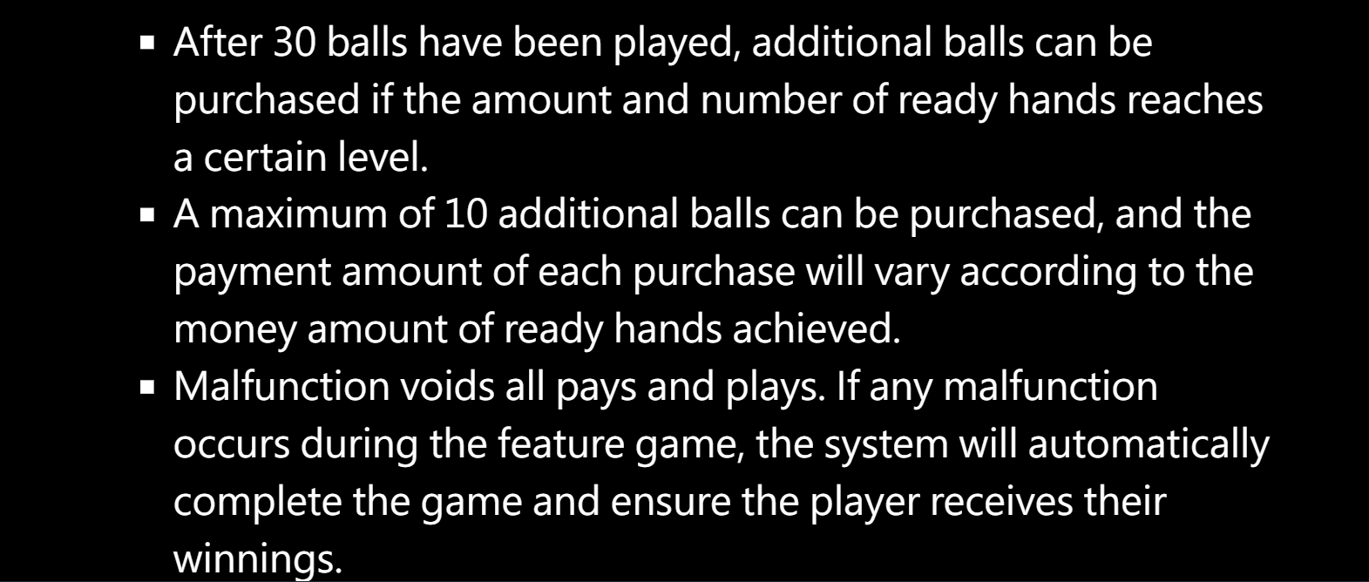

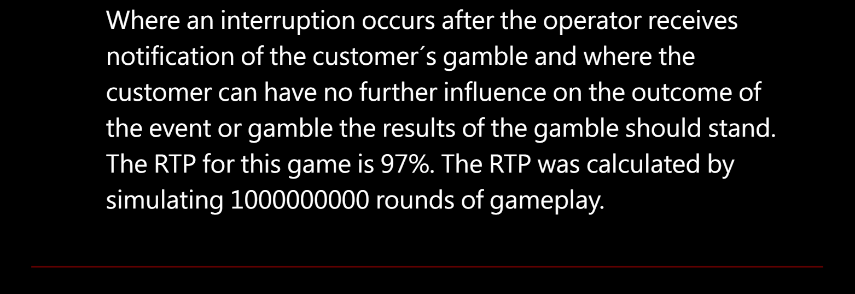

* You can buy 1~16 bingo cards per game, the more you buy, the higher the chance you win.
* If you complete any of the paylines in the chart, you will receive the corresponding payout.
* Once the prize line is completely covered by a prize lin with higher odds, the prize with the highest odds will be taken.
* The odds are calculated based on the unit price of the bingo card.
* After 30 balls have been played, additional balls can be purchased if the amount and number of ready hands reaches a certain level.
* A maximum of 10 additional balls can be purchased, and the payment amount of each purchase will vary according to the money amount of ready hands achieved.
* Malfunction voids all pays an plays. If any malfunction occurs during the feature game, the system will automatically complete the game and ensure the player receives their winnings.

Where an interruption occurs after the operator receives notification of the customer’s gamble and where the customer can have no further influence on the outcome of the event or gamble the results of the gamble should stand.

The RTP for this game is 97%. The RTP was calculated by simulating 10000000000 rounds of gameplay.

# UI

## Winning Ways

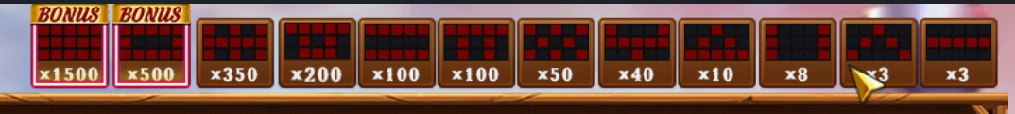

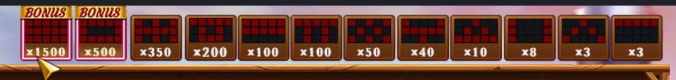

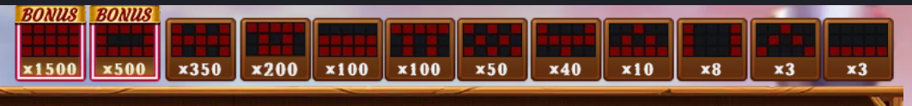

16ways

*100 3ways

*3 3ways

## CARD UI

1-16 CARD

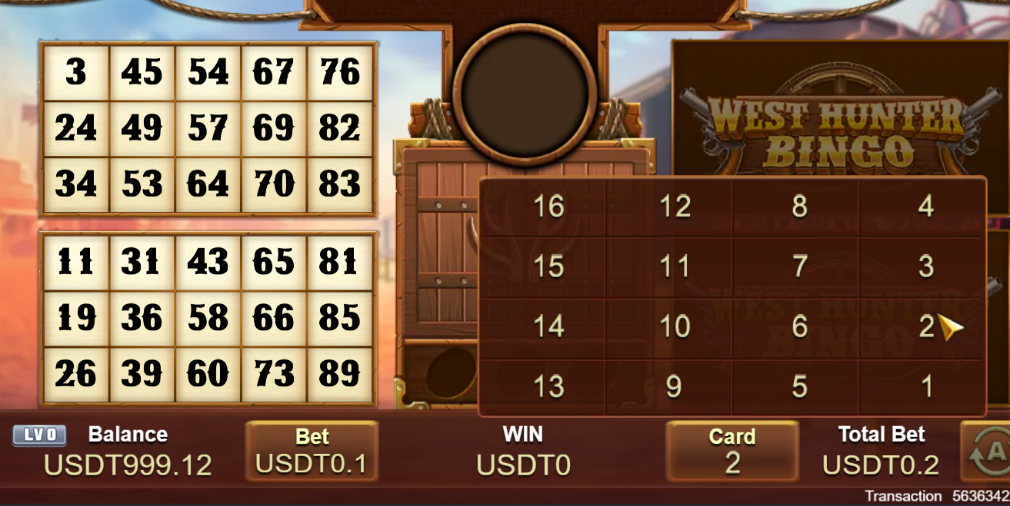

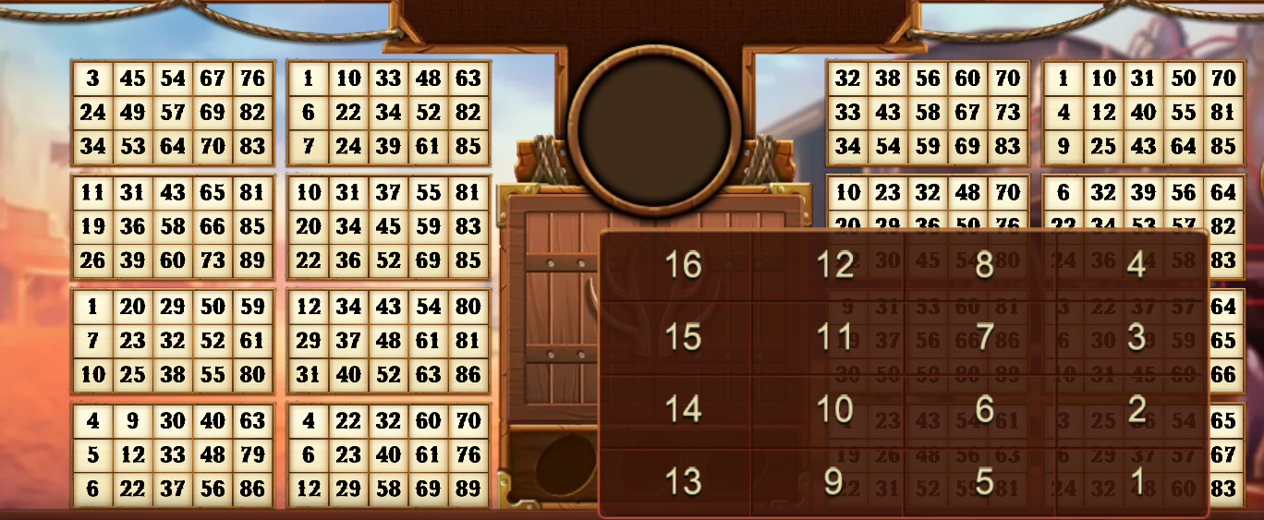

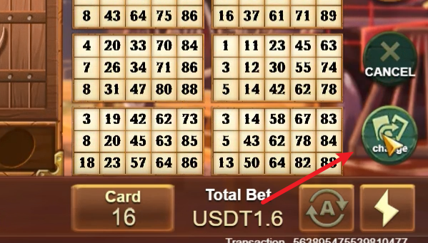

## Golden Ball UI

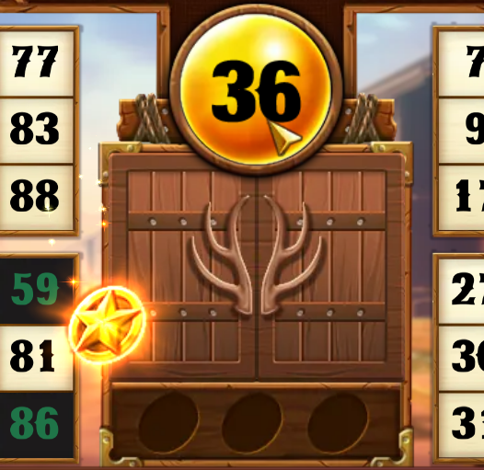

## Bouns Game UI

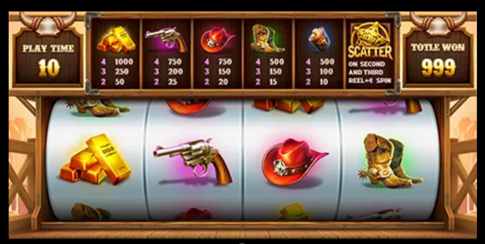

## WILD BALL UI

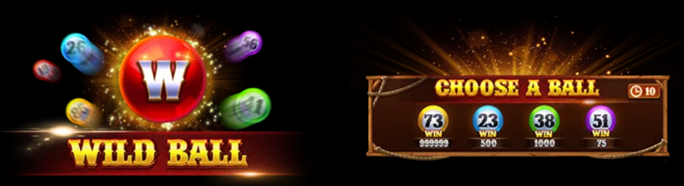

Choose the nuble in 10 second

## Additional bolls UI

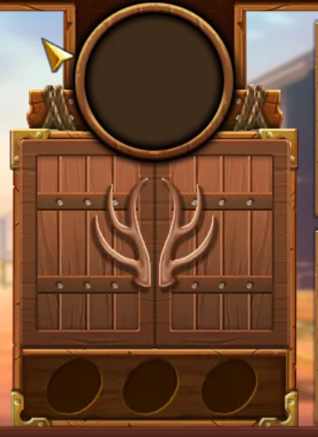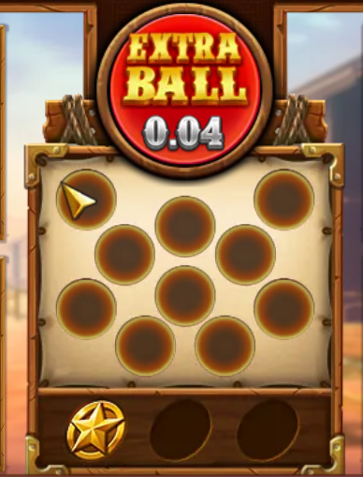

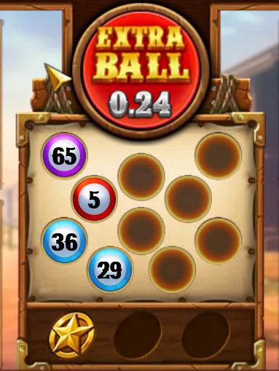 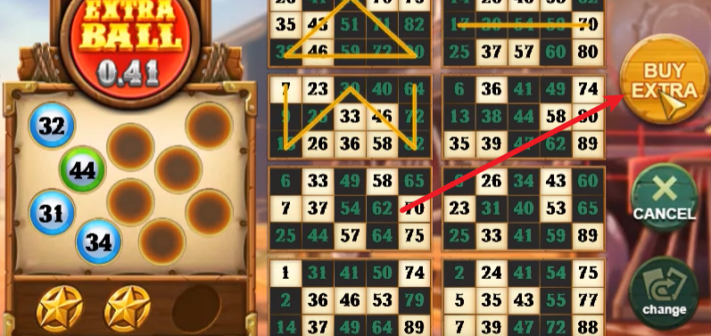

## SPIN UI

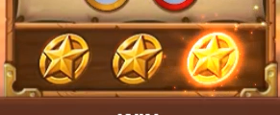 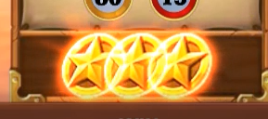

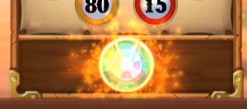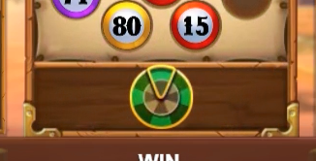

Collect 3 gold coins to activate the wheel and receive an extra reward at the end.

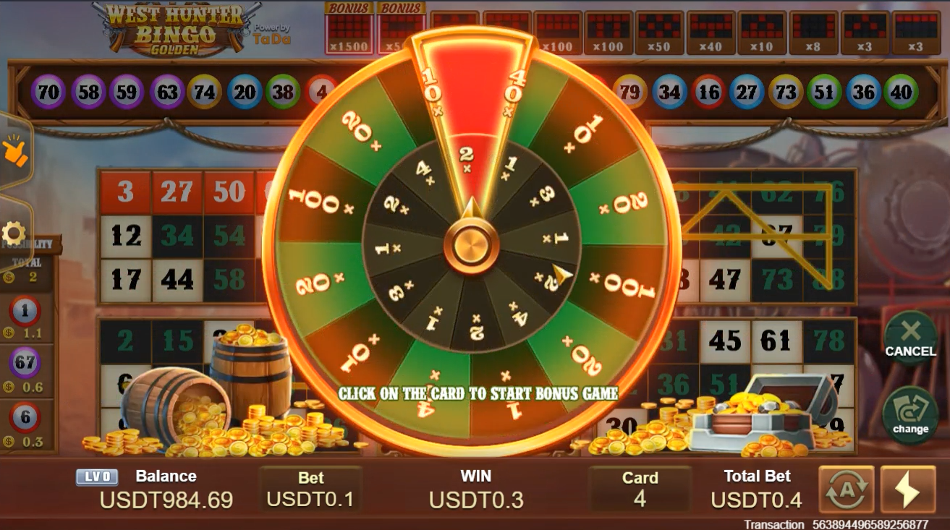

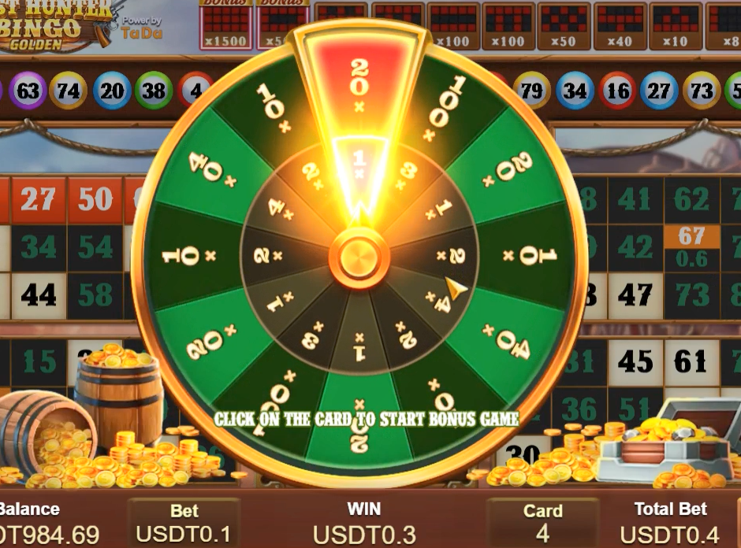

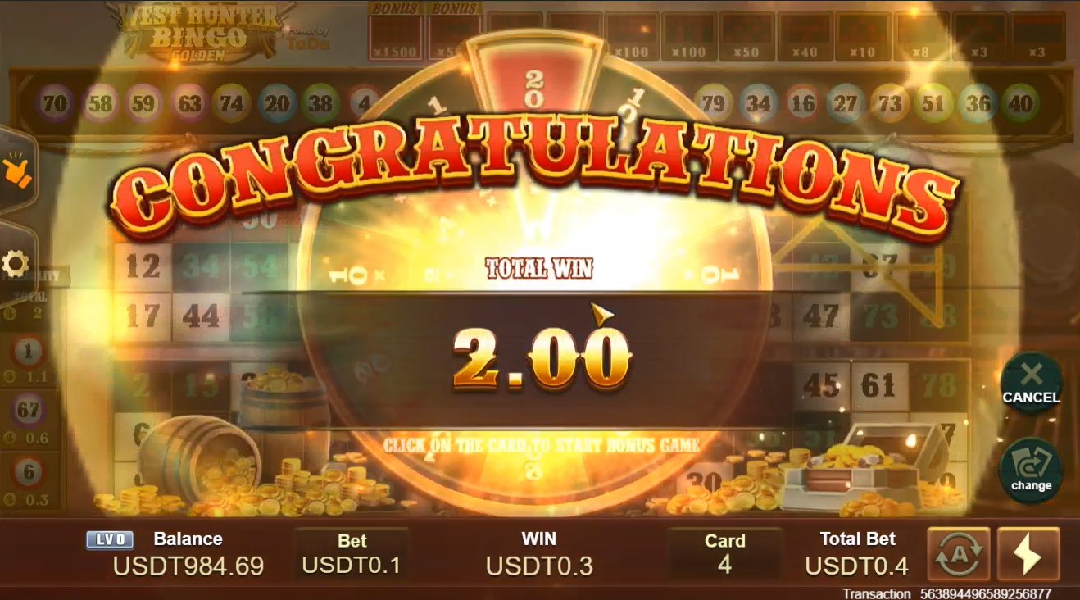

## FREE BOLL UI



Click within 10 seconds to get a number for free.

## BET UI

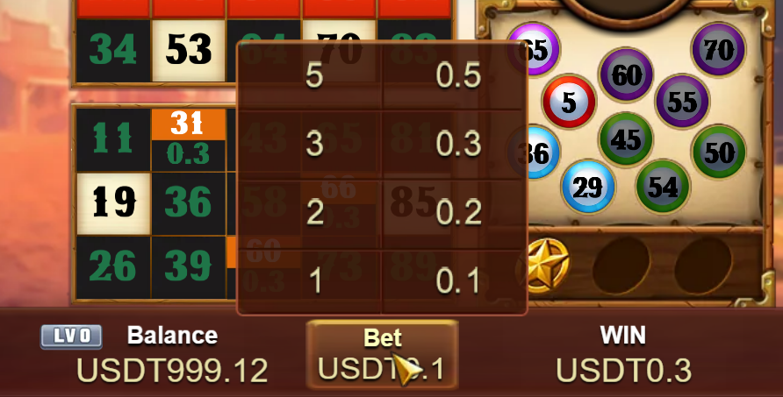

0.1,0.2,0.3,0.5,1,2,3,5

## WINNING UI

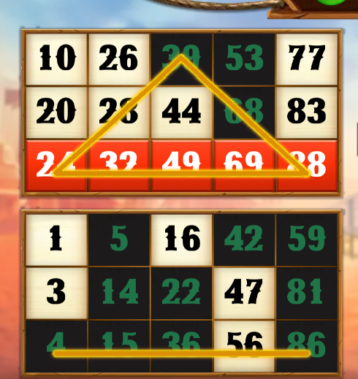

## Possibility UI

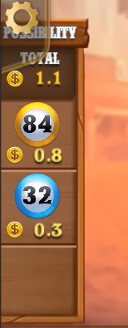 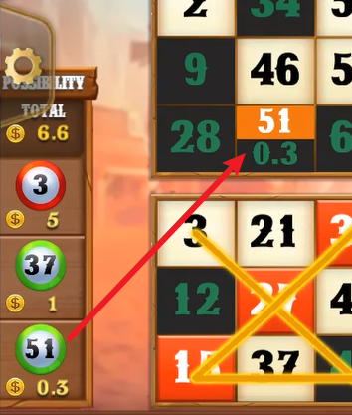

If a certain number appears, the prize amount will increase by how much.

## AUTO UI

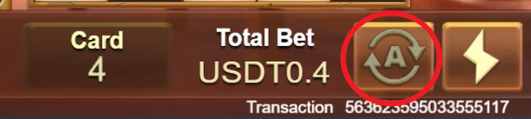

After activation, a countdown will be displayed here. Click to stop.

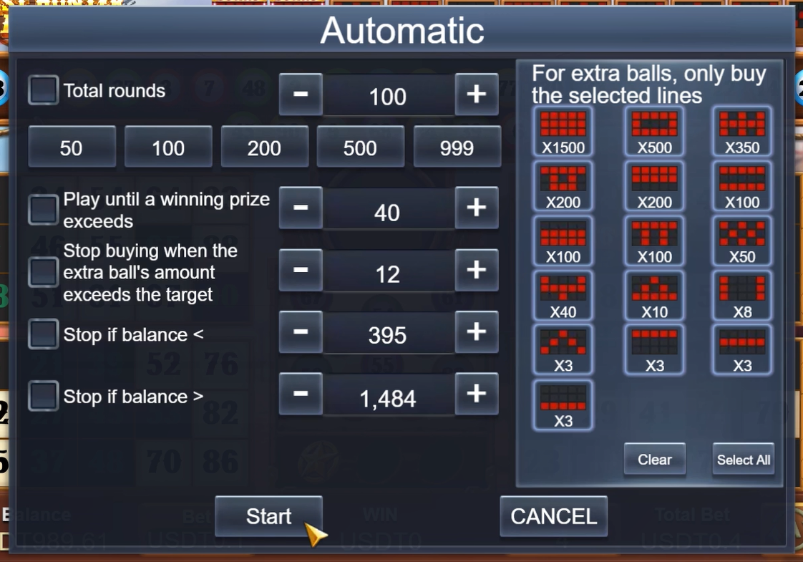

## Fast UI

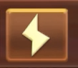on 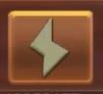off

## History

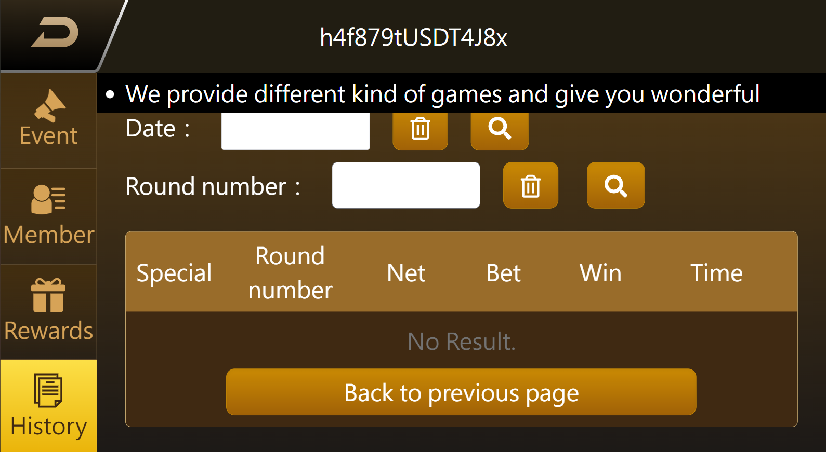

• History

• Round Number: System

• Bet: Total Bet

• Payout: Total Payout

• Time: YYYY-MM-DD HH:MM:SS

• No Result – Message Prompt

# Automatic

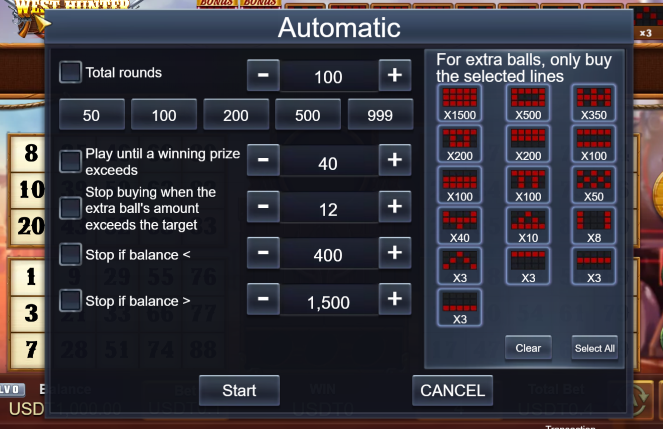

Automatic

Total rounds

Play until a winning prize exceeds

Stop buying when the extra ball’s amount exceeds the target

Stop if balance <

Stop if balance >

Start

For extra balls, only buy the selected lines

Clear

Select All